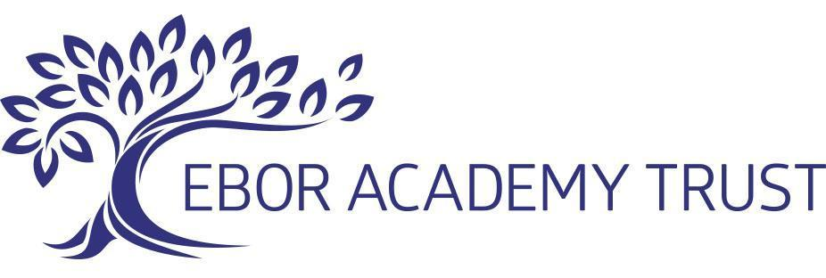

Policy Number
Remote Teaching and Learning Policy
26NS

Approved By: Standards Committee
Approval Date: Jan 2023
Review Period: Every 3 years

Review Date: Jan 2026

Author: Executive Headteacher (Adapted from Michael Hall, a Steiner Waldorf School)
Date Created/updated: Jan 2023
Version Number: 2

Policy Amendments Summary Sheet
Date | Amendment to Version Number: | Page: | Section: | Sub Section: | Amendment | Date Amendment Approved | Amendment Approved by
Mar 2022 | 1 | 2 | 3 | 3.1 a and k-o | As remote sessions can no longer be recorded, all references to recorded sessions have been deleted.

Contents:

1. POLICY STATEMENT 2
2. STATEMENT OF INTENT: Wellbeing & Pastoral Care 2
3. STAFF RESPONSIBILITIES for remote teaching 3

- POLICY STATEMENT
This policy applies to all schools within the Ebor Academy Trust, which includes any students on roll. This policy is reviewed and updated annually (as a minimum). This policy is informed by the following guidance and advice:
Keeping Children Safe In Education (September 2021) (‘KCSIE’)
Working Together to Safeguard Children (July 2018)
Professional Code of Conduct for Staff
Guidance from the Key for School Leaders: CoronaVirus
SLES Safeguarding Team Standards and Learning Effectiveness Service
(SLES.Safeguarding@eastsussex.gov.uk)
Corona Virus: Additional Guidance for Schools -(czone.east sussex.gov.uk) LGfL DigiSafe https://coronavirus.lgfl.net/safeguarding
Andrew Hall (www.safeguardinginschools.co.uk)

This policy also takes into account the guidance offered by City of York Council, North Yorkshire County Council, East Riding of Yorkshire Council and Hull City Council as part of the interagency safeguarding procedures set up by Local Safeguarding Children Boards.

- STATEMENT OF INTENT: Wellbeing & Pastoral Care

At Ebor Academy Trust we are committed to safeguarding children and young people and we expect everyone who works in our Trust to share this commitment and join us in creating a culture of vigilance.

- Adults in our schools take all welfare concerns seriously and encourage children and young people to talk to us about anything that worries them and be confident that they will be listened to and taken seriously. We will always act in the best interests of the child and we recognise the importance of maintaining an attitude of ‘it could happen here’.
- We continue to take a whole school approach to safeguarding and child protection, so that awareness is raised within the entire school community. This policy defines a child as anyone under the age of 18 years and applies to all members of staff, including permanent, temporary and ancillary staff, Council Members, volunteers, contractors and external service or activity providers.

- We teach pupils about safeguarding, including online, through various teaching and learning opportunities, as part of a broad and balanced curriculum. The updated Ofsted guidance seeks to ensure that children ‘recognise when they are at risk and how to get help when they need it’.
- A secure and caring culture is essential in creating a safe learning environment for each child and we aim to create a caring, positive, safe and stimulating environment that promotes the social, physical, emotional and moral development of the individual child. We recognise that all Schools and the Trust play a significant part in the prevention of harm to our pupils and that creating an overall ethos of protection with good lines of communication are essential and will further support those children who may have heightened vulnerability within our Trust such as SEN-D children, those suffering peer-on peer abuse and those vulnerable to radicalisation or exposed to extremist views.
- This policy has been created to ensure that all our pupils are effectively safeguarded whilst they access online learning opportunities from their homes for the duration of their long distance and remote learning period.
- Safeguarding and child protection is everyone’s responsibility. Everyone who comes into contact with children and families has a role to play. Our school is a community and all those directly connected, staff members, Council Members, parents, families and pupils, have an essential role to play in making it safe and secure.
- STAFF RESPONSIBILITIES for remote teaching

- Online platforms:
‘Google’ is the only permissible platform for teaching online video-based lessons Ebor Academy Trust/School Name here?. ‘Google’ will not be used for communicating with parents, neither is it to be used for one to one communication with students and is only to be used for teaching students of class nine and above.
In the instance of Teaching Staff delivering a lesson through ‘Google’ they will observe the following procedures:
- When staff are hosting an online lesson, it must be set up with an @ebor.academy email address.
- Online classroom sizes must consist of 2 or more students.
- For certain children, one to one learning may be deemed necessary. In this instance the teacher must:
- First apply for, and receive permission from the DSL
- Receive written confirmation from the student’s parent in writing that they are happy for a 1 to 1 teaching session to be taught
- Ensure that the child’s parent is in the same room as their child or in close proximity.
- Once a teacher has scheduled an online classroom, the teacher must only send the link to the students’ Ebor email account.
- If the student has forgotten their password the teacher must request the students’ password be reset.
- When teaching in an online classroom, staff need to be business-like when giving lessons: presenting themselves as professionally as they would if they were giving a face-to-face lesson, in dress and in manner: Staff should remember that while social media applications can encourage informality, they need to observe their usual high professional standards at all times.
- The broadcast should only take place from an appropriate communal area of their house or area of work. E.g. living rooms, kitchens, home offices and gardens.
- If delivering lessons from home, be aware of material that may be visible in the background. Avoid revealing any personal teacher information or other sensitive data.
- The teacher of the hosted classroom must remove any students from the online classroom who have not followed the school dress code or are deemed to be wearing inappropriate clothing. The student may join the classroom again once the issues have been resolved.
- Emailing:

All lesson plans and work set, is accessed via the secure Distance Learning page on the school's website and is available to students and their parents.

Only pupils from class 8 upwards can be emailed directly as they have been issued with school email addresses.

Staff are only permitted to email students at their school issued address and from their own school account. Individual emails should be focused on educational matters and another parallel colleague such as tutor, guardian or class teacher should always be copied in. Any concerns arising of a wellbeing pastoral nature MUST be recorded on CPOMS.

- Microsoft Teams:
This is the only permissible ‘chat’ room part of Office 365 hosted by the School’s system that school staff may use. Staff must set this up for a group of more than two students, it cannot be used for one to one dialogue. This forum is only to be used for class eight and above

- Microsoft Sharepoint
SharePoint is a web-based collaborative platform that integrates with Office 365. SharePoint is a document management and storage system. Teachers can provide a link to their libraries of resources for a whole class, provide differentiated learning and share academic information with individual students (and tutors) such as academic performance, RAG trackers, and practical skills advice.

